

Learning Lessons From TEFL: The Flip Side

Lesson Objectives:
Main aim: Learners will be able to discuss the use of and decide on antonyms to rewrite a famous poem
Subsidiary Aims:
•Learners will show they are able to discuss their views on poetry, identifying oxymorons and exploring metaphors
•Learners will develop listening subskills while following an audio recording of a poetry recital
•Learners will show they can analyse a poem and construe meaning from imagery

Level: C2

Materials needed: Google Slides presentation which includes an animated Ted video of ‘The Opposites Game’ poem by Brendan Constantine, a copy of the poem ‘Alone Together’ by Brian Bilston and “The Road not Taken” by Robert Frost.

Procedure

Stage 1
Warmer: Project the title screen and elicit what ‘the flip side’ is – the opposing perspective of something – and some example.
Ask students to predict what they think the lesson will be about from the title and explain it will focus on opposites.

Stage 1 – Exploring antonyms
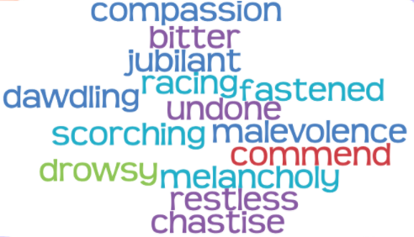
Project (or board) the word cloud of different antonyms and give students 5 minutes to try to find the pairs. Feedback as a class and check comprehension. Ask them to identify what parts of speech they are and then ask them to write sentences using them to record them in a meaningful context.

Antonym pairs:
compassion – malevolence
fastened – undone
dawdling- racing
commend – chastise
drowsy - restless
jubilant – melancholy
scorching - bitter

Stage 2: Oxymorons
Project the poem ‘Alone Together’ by Brian Bilston. Give students a few minutes to read it and discuss in pairs what the poem is about. (a relationship between two opposites written using oxymorons)

Elicit what an oxymoron is and give students some time to identify all the oxymorons in the poem. What is their effect?

Ask students to consider whether all the terms in the oxymorons are in fact polar opposites? Is the opposite of civil really war? What other words might you substitute it with? Where would you grade your alternatives if you had to arrange them on a cline or sliding scale?

Give your students 5 minutes to discuss if they are aware of any other oxymorons in English. Ask them, if not, if they can invent some and share with the class.

Stage 3: The Opposites Game
Ask students if they are familiar with the poet Brendan Constantine and if so, have they have ever heard of ‘The Opposites Game.’ Explain that is it is a game invented by Brendan Constantine that he would play with his English students involving poetry. Ask them to discuss what they think the game might be.
Play the video until 00:59 for students to see if their ideas were right.

Elicit what the game is and why the students stopped. (Constantine would give his class the first line from a famous poem and ask students to give him the antonyms word for word. They stopped when they had to give the antonym for ‘gun’ to think of their responses.

Put students in pairs and give them three minutes to discuss what they believe the opposite of ‘gun’ is.
Play the rest of the video for students to see if their ideas were mentioned and to hear the rest of the poem.

Ask students to retell the narrative of the poem in pairs.
Give them a copy of the poem (link in presentation) Ask them to look at the different imagery in the poem and discuss why each is proposed as the opposite to ‘gun’.

Ask students what they understand from the last three lines of the poem and their response to the poem.

Stage 4: Writing an opposite poem
Project ‘The Road Not Taken’ by Robert Frost.
Give students a few minutes to read the poem and then discuss together the meaning of the poem. Feedback as a class.

Divide students into pairs and ask them to rewrite the poem word for word using antonyms. Does the poem still make sense? Do they need to make any changes to their translation to make it more readable while still maintaining the original sense?

Share rewritten poems with other pairs and discuss the differences.

