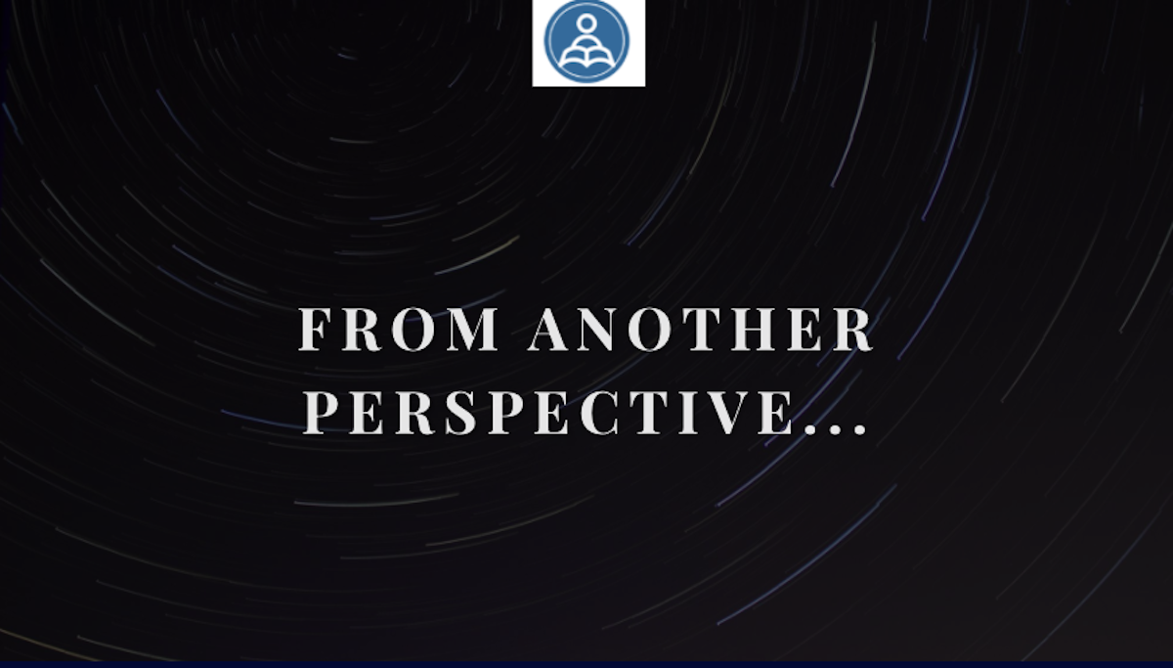

Learning Lessons From TEFL: From another perspective

Lesson Objectives:

Main aim: Learners will be able to problem-solve using the second conditional while developing listening and speaking skills
Subsidiary Aims:
•Learners will show they are able to discuss their views on humanity and the world around us, showing emotional literacy.
•Learners will develop listening subskills as they listen and interact with a story.
•Learners will develop their critical thinking skills as they discuss and find solutions for various problems.

Level: This lesson was intended to be used with a group of Upper-Intermediate students as a way of reviewing the second conditional while introducing some new vocabulary.

Materials needed: Genially Presentation

Procedure

Stage 1
Warmer: Students discuss together the following questions to activate schema and to give the teacher a chance to assess how they use the second conditional
- What are you scared of?
- Do you have an overactive imagination?
- If you had to make an important decision quickly, how would you feel?

Stage 2 - Listening and pair work speaking 10m:
For the audio, click on the arrow in the top left hand corner. Alternatively, read the script yourself.

“I’m not very good at making decisions; I suppose you could say I’m indecisive, or perhaps impulsive, whichever it is, I always seem to find myself in the most difficult and dangerous of situations, and then I freeze and panic…”

This can either be done as a listening or dictation activity. Once students have heard the introductory sentence they discuss together in breakout rooms:
- What’s the difference between indecisive and impulsive?
- Why could this sentence be considered funny?
- What situations might cause you to ‘freeze and panic’?
- Tell your partner about a time when you have found yourself in a similar situation.

Stage 3: Discussion

“I’m going to put you in my shoes so you can live a day in my brain. I hope you can help me on my way.”

Students discuss together: Have you ever thought about living another person’s life for a day? If you could choose anyone who would it be? Why?

Stage 4: Grammar presentation and controlled practice:

If you could choose anyone, who would it be and why?

Ask students: What conditional is this? Elicit it is the interrogative form of the second conditional. What is the form? Elicit positive, negative and interrogative forms. Highlight that they use If + past, and would (or another modal) + bare infinitive in the result clause. In which situations do we use a second conditional? Elicit it is used for hypothetical situations, in future and present situations which are improbable. How can we use it to give advice? Elicit “If I were you, I’d…” Point out that we use the subjunctive here and so it is far more natural to say “If I were you” rather than “If I was you”

Controlled practice: Tell students to read the situations and write sentences using the second conditional to give advice. Compare in small groups and decide whose advice you think is best and discuss why.

Stage 5:

“So, I’m lying in bed and my alarm goes off, it’s a Monday morning and I’ve had a bad night’s sleep. I pick up my phone and look at the screen. The ‘Snooze’ function flashes at me. What should I do?”

Tell students to discuss the options, encouraging them to use the second conditional where they can.

Stage 6:

“I choose to ‘snooze’ but then I hear a strange noise. It’s a noise that I’m not used to and it makes me sit up in bed. Still confused I sit perfectly still, pulling the covers up to my eyes. And I hear it again...It’s a strange sound, a soft repetitive thud. It sounds like this…. I can’t understand it. I live alone.”

Give students a few minutes to discuss what it sounds like (in Breakout rooms) with audio. Link: https://voca.ro/13xMGpGS2LFM
Class feedback to share suggestions

Stage 7 - Scavenger hunt and justification

“As it gets louder, it feels like it’s getting closer. Instinctively, I reach out for my mobile phone, but the screen doesn’t come to life when I touch it; it’s out of battery. I realise my charger is in the living room so I am now without a telephone, without any connection to the outside world, and with just a disturbing noise to keep me company. As my heart beats faster, I decide I must act. I need to find out what this noise is and make my escape if I need to! But I feel vulnerable. I look around the room for something to take with me to make me feel braver. What should I take?”

Tell students that they have 1 minute to find something in their house/classroom that I can take with me. When they have returned, split the students into groups and ask them to present their item to the group and discuss why it would be useful in this situation. Together they must decide on two items to take (one in my hand and one in my pocket)

Stage 8 - Drawing challenge

“I open the door; someone is there but I am not scared. It’s not really a human, it's a mix between an animal and a person. It is clear that it’s nothing I’ve ever seen before and I suddenly realise that I am now looking at some kind of alien life form…”

Tell the students they have 3 minutes to draw the alien and then do a reveal in the main session. Students can simply do this on pieces of paper or if you want to use a more hi-tech version you can set up a room using whiteboard.fi and they can draw their aliens there.

Stage 9 - Description

“It talks to me. and explains it’s on a fact-finding mission from another planet and wants to explore what life is like on Earth and then report back. Everything is new and different here and it can’t understand what we do and what things are. For example, the things I am holding in my hands… what are they?”

Tell students that their next challenge is the art of accurate description. They must work together to define their objects as if they were describing them to an alien with no knowledge of function.

Stage 9 - Groupwork

“It’s strange, I see a stunningly beautiful planet that you don't care about. Beautiful oceans, full of plastic. Green forests and big machines that make them less green. Humans who are equal but aren't. Emotions and feelings which people can’t share and don’t want to talk to. Unwritten rules that everyone follows even though they make no sense. It’s confusing. Are the objects you are holding representative of human life? If not, what items can I take back which show what it means to be a human? How can we be human?

Tell students that to conclude the lesson they have to react and respond to what the alien said.
- How can you explain the problems with civilization that the alien has noticed?
- In groups, discuss what objects or concepts epitomise being human.
- If you had to write a “how to be human” guidebook, what would it include?

Follow up writing activities

- Ask the students to write a ‘How-to-human’ guide at home.
- The story ends abruptly, what happens next? Write the ending. Does the alien decide to stay?
- The alien invites you to visit their planet. Write a description of the planet and compare it to Earth.

